FAMILY CONNECTIONSTM
A skills-based program that offers a
lifeline to families facing
Borderline Personality Disorder

THE NATIONAL EDUCATION ALLIANCE FOR BORDERLINE PERSONLITY DISORDER

invites you to attend a special Washington, DC area
Family Connections Weekend Workshop
at George Mason University

April 22 & 23, 2017
(8:30am – 5:00pm)

COURSE CONTENT:

• Research-based program typically
taught as 12-week course
• Education & Research on BPD
• Skills training for families based on
Dialectical Behavior Therapy
• Relationship Mindfulness
• Effective Communication
• Validation
• Development of a support network

HOW TO REGISTER:
Request the Washington DC Weekend Workshop when registering at www.borderlinepersonalitydisorder.com/family-connections

Note: Space is limited and registration is first come, first serve. This workshop is NOT open to people who suffer from BPD, only to family members and close friends. A voluntary $50 donation is requested to cover printing & administrative costs. No one will be turned away for financial reasons. For questions contact meg@borderlinepersonalitydisorder.com

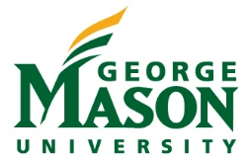
SPONSORED BY:

George Mason University’s Center for Psychological Services
http://psyclinic.gmu.edu/

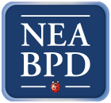
National Education Alliance for Borderline Personality Disorder
www.borderlinepersonalitydisorder.com

